Asset Walk 6-9 weeks

Project: Triarc Tank
Date of Walk-Thru | 07/05/2023
AHU/RTU
RA & OA damper installed | Yes
Piping complete | Yes
Ductwork Connections Finalized and Sealed to Unit (OA, Return, Relief, Supply) | Yes
Power Landed to Unit/VFD | Yes
Comments
Exhaust Fans
Unit Mounted to Correct Curb/Location | Yes
Disconnect Available | Yes
Power to Fans/VFD | Yes
Duct connected to fan/curb | Yes
Motorized Dampers Installed | Yes
Comments
Return Air Path (marked up drawing attached)
Are there enough transfer openings | Yes
Are they sized correctly | Yes
Are they in the correct location | Yes  Notes/Comments:  Notes/Comments:
Comments | Transfer missing Rm 405 , 2 transfers added in Rm 409.
VAVs
VAV Hanging & Present | Yes
Inlet Duct connected | Yes
Discharge Duct connected | Yes
Unit Powered & Operational | Yes
Piping to reheat coil complete | Yes
Balance dampers installed and open | Yes
Comments

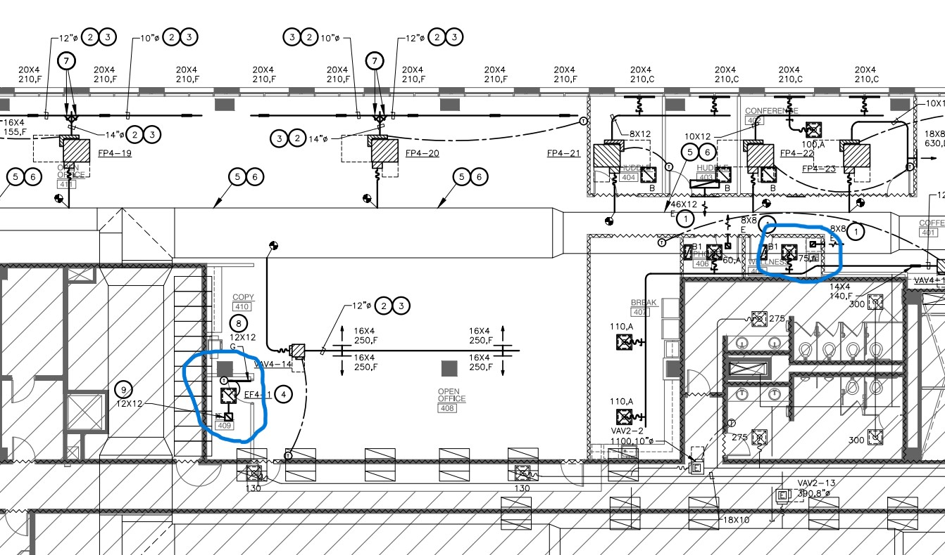
2 new Transfers Here: Missing Transfer Here:

Room 409:

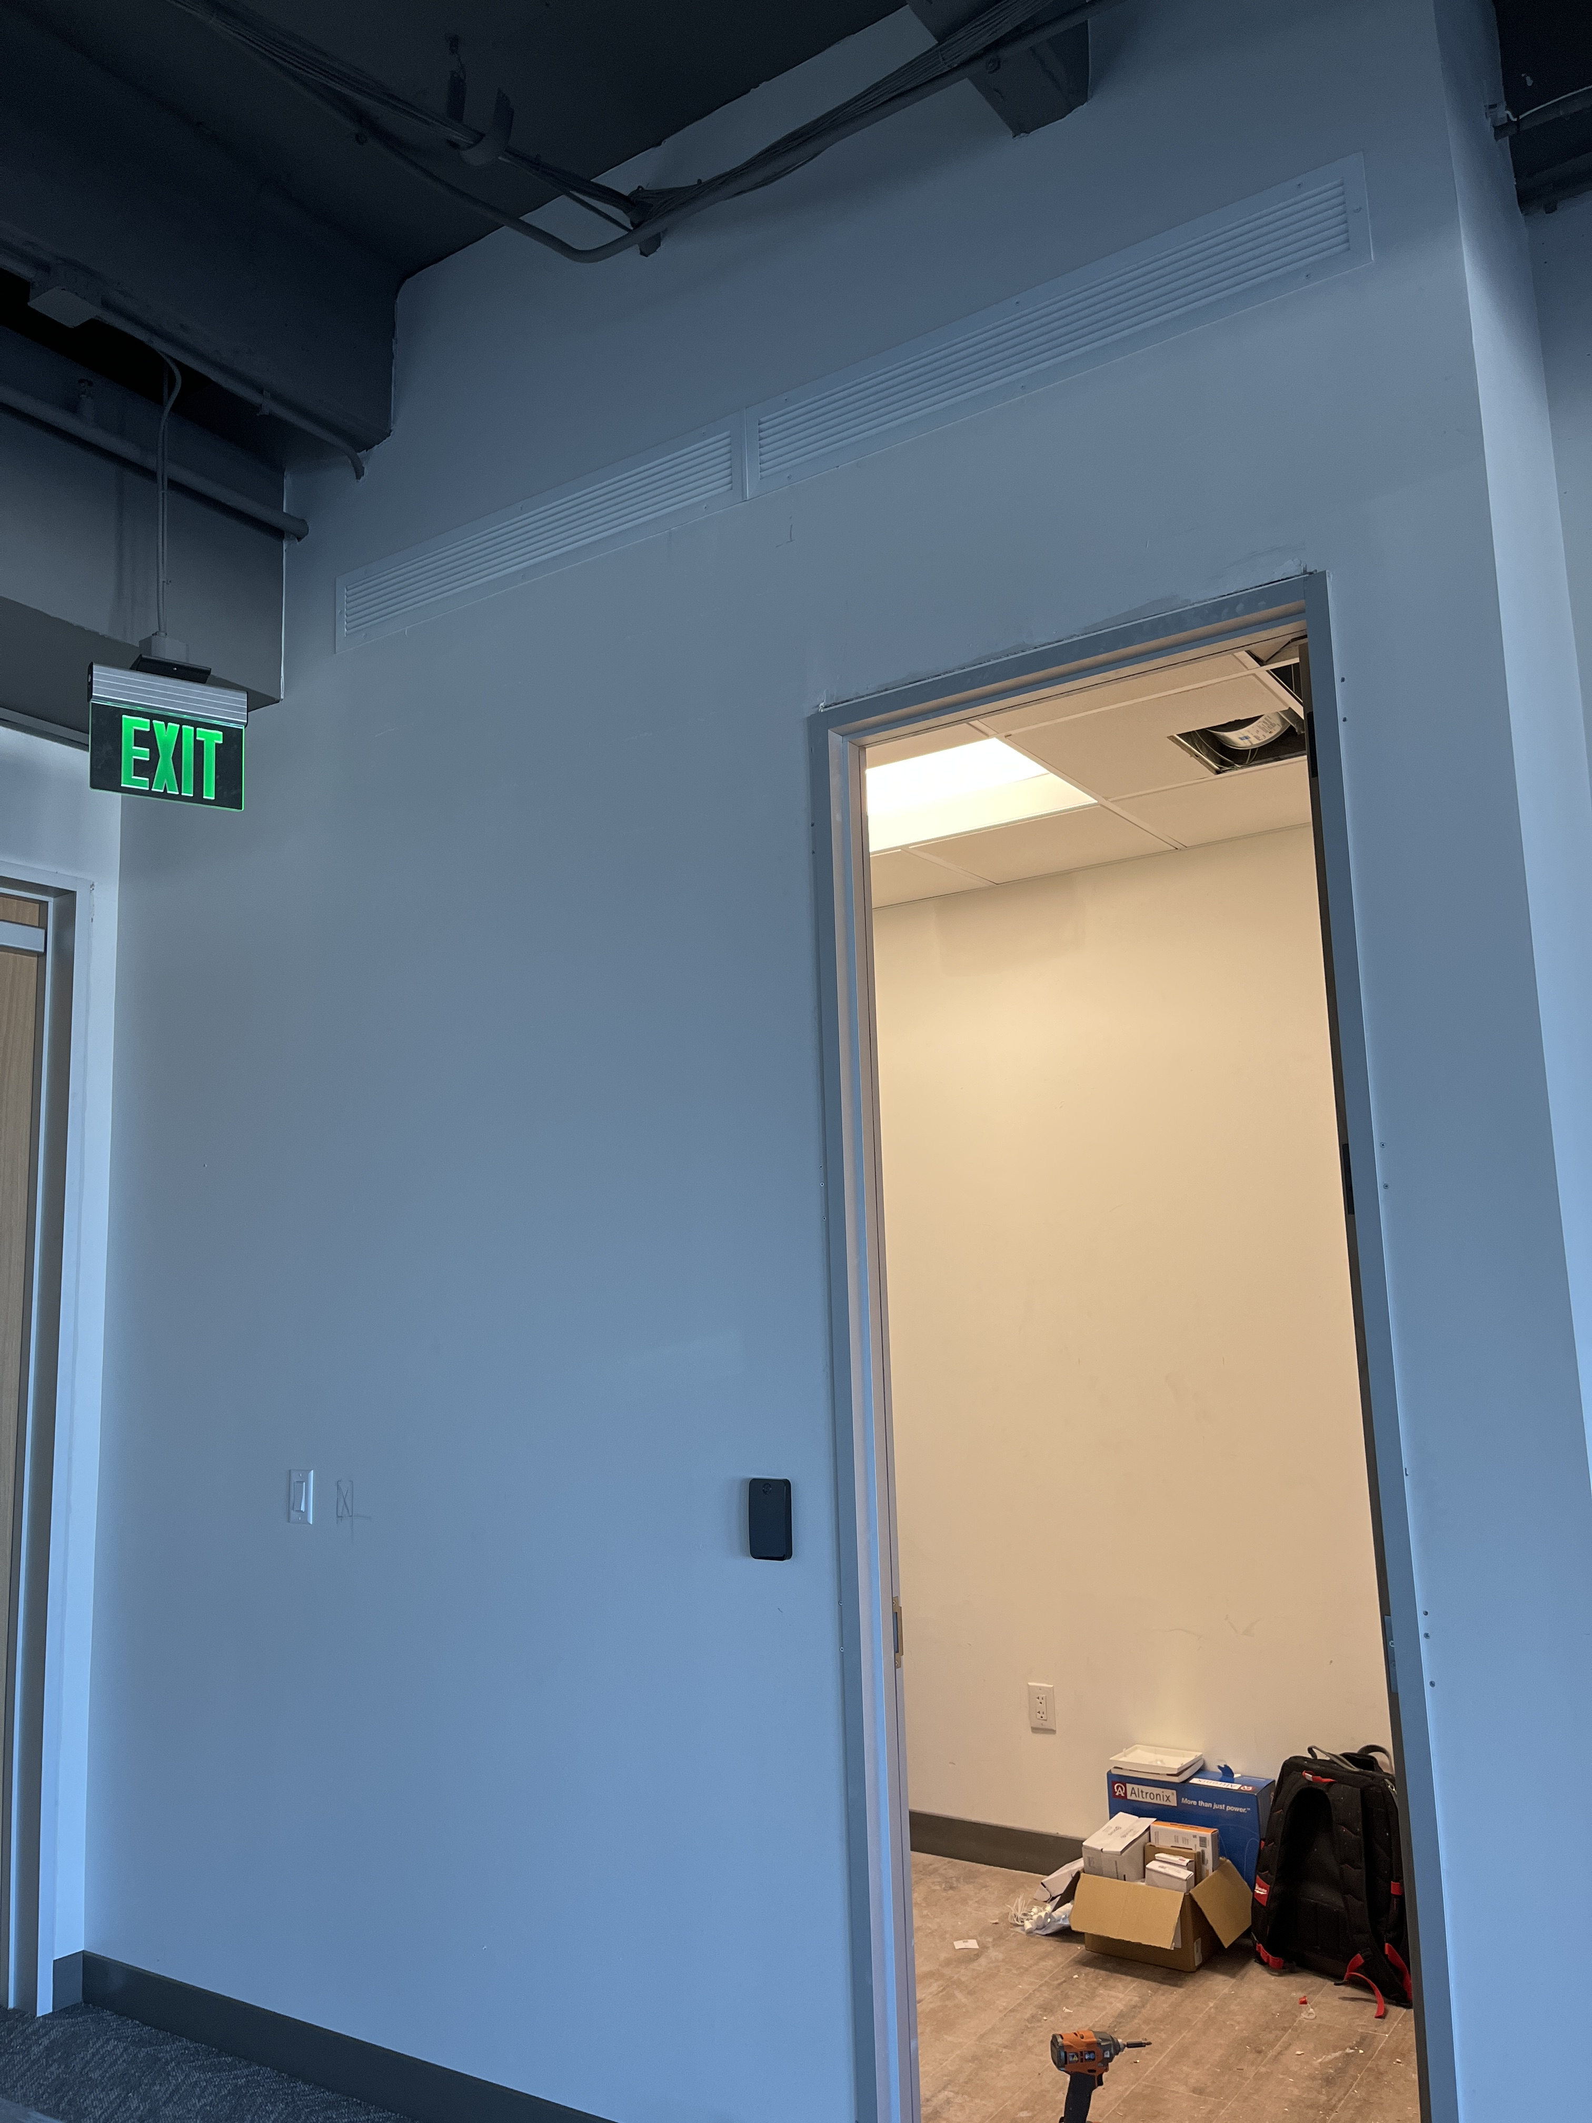

Room 405:

